

|  |  |  |
| --- | --- | --- |
| **MATHEMATICS DEPARTMENT** | |  |
| **Course:** **ATMAA** | |
| **Topic Title**: **Skills Test 11** | |
| Student Name:_____________________________________ | Date: __________2016 | | |
| Special Instructions: Calculators Allowed | Time Allowed: 20 mins | | |
|  | Marks: / 16 | | |

**Question 1 (4 marks)**

Write the adjacency matrix for the digraph below.

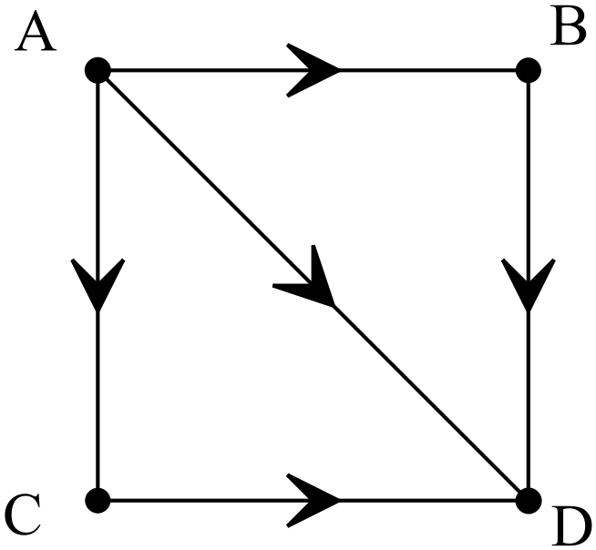

**Question 2 (4 marks)**

Write the adjacency matrix that shows the two stage pathways for the digraph below.



**Question 3 (marks)**

Find the critical path for the network below, and hence find the shortest time for project completion. Times are in days.

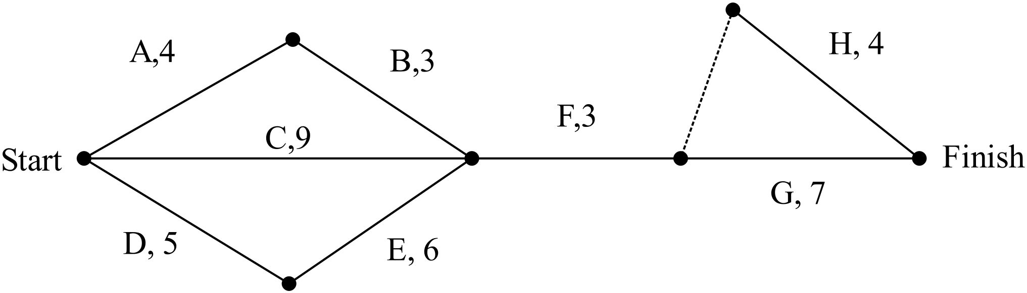

**Question 4 (marks)**

Construct a project network for a project that consists of the following tasks:

|  |  |  |
| --- | --- | --- |
| Task | Time | Immediate Predessors |
| A | 7 days | - |
| B | 4 days | A |
| C | 10 days | B |
| D | 3 days | B |
| E | 4 days | B |
| F | 6 days | A |
| G | 3 days | F |
| H | 7 days | F |
| I | 5 days | E, G |
| J | 7 days | D, H, I |

